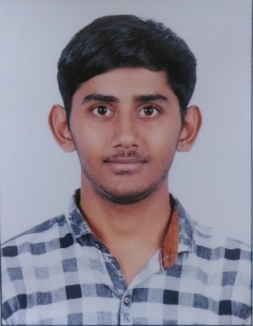 **Curriculum Vitae**

Kishan Riteshbhai Nakrani

206, Madhavbaug Society, Ugat Bhesan road, Jahangirpura,

Surat.

[nakranikishan98@gmail.com](mailto:nakranikishan98@gmail.com)

7573062203

|  |
| --- |
| **Summary** |

I am Kishan Nakrani , as a recent third year BCA college student, where I am doing cyber security course with network administration knowledge, include back-up, security management, e-mail system and applications support. Where I got the news from the Gujarat Samachar at 25/9/2018 as your company systemnext Pvt Ltd need the post for hardware engineer.

Looking forward to an opportunity for working in a dynamic, challenging environment, where I can utilize my computer skill in all phases of the hardware and software development cycle.

|  |
| --- |
| **Academic Education** |

|  |  |  |  |
| --- | --- | --- | --- |
| **Qualification** | **University** | **Year Of Passing** | **Percentage** |
| SSC (English Medium) | GSEB | 2014 | 60 % |
| HSC (English Medium) | GSEB | 2016 | 45 % |
| BCA (Persist) | VNSGU | - | 7 CGPA |

|  |
| --- |
| **Skill and Area Of Interest** |

1. Learning with security and database information management tools.

2. Interesting to be capable of working with various types of networks, capable of analytical reasoning and

applying logic to situations.

3. Able to manage and work with different types of network firewalls.

4. Known with various programming languages.

5. An ability to work together with a large team.

|  |
| --- |
| **Personal Skill** |

1. Good at finding fast and effective solution to various problems.

2. Very organized and disciplined.

3. Respectful, well-mannered, and punctual.

|  |
| --- |
| **Hobby** |

Self Motivation

|  |
| --- |
| **PERSONAL DETAILS** |

Name : Kishan Nakrani Riteshbhai

Date Of Birth : 24/06/1998

Age : 20

Gender : Male

Place Of Birth : Surat

Language Known : English (R,W,S), Gujarati (R,W,S), Hindi (R,S)

Nationality : Indian

Religion : Hindu

Sub caste : Leva Patel

|  |
| --- |
| **Contact Detail** |

Email : nakranikishan98@gmail.com

Contact No. : 7573062203

Full Address : 206, Madhavbaug Society, Ugat Bhesan road, beside Raj Harmony, Jahangirpura,

Surat.

|  |
| --- |
| **Declaration** |

I hereby declare that the above information is true to be the best of my knowledge and belief.

Hoping for the good reply.

**Place** :

**Date** : 29-9-2018

Your faithfully

Kishan Nakrani